# Laporan Pemograman Dasar

**Memenuhi Tugas UAS Semester 1**



# Oleh :

**Ferry Septian Ferdiyanto E41191224**

**D-4 Teknik Informatika B**

**JURUSAN TEKNOLOGI INFORMASI POLITEKNIK NEGERI JEMBER 2019**

**Tugas Pemrogaman Dasar UAS Semester 1**

1. **Frame**

**Screenshot**



1. **Index**

<html lang="en">

<head>

    <meta charset="UTF-8">

    <meta name="viewport" content="width=device-width, initial-scale=1.0">

    <meta http-equiv="X-UA-Compatible" content="ie=edge">

    <title>TUGAS UAS</title>

    <frameset rows="25.4%,*,10%" border="1">

        <frame src="header.html" name="header"></frame>

        <frame src="content.html" name="content">

        <frame src="footer.html" name="footer">

    </frameset>

</head>

<body>

</body>

</html>

1. **Header**

<html lang="en">

<head>

    <meta charset="UTF-8">

    <meta name="viewport" content="width=device-width, initial-scale=1.0">

    <meta http-equiv="X-UA-Compatible" content="ie=edge">

    <title>Document</title>

    <style>

        .header{

            width: 100%;

            height: auto;

            background-color: #22293c;

        }

        .header h1{

            padding-top: 15px;

            padding-bottom: 0px;

            text-align: center;

            font-size: 50px;

            color:snow;

            font-family: fantasy;

        }

    .header h3{

        padding-left: 10px;

        font-size: 15px;

        color: #c0392b;

        font-family: cursive;

    }

    .header label{

        float: right;

        margin-top: -22px;

        padding: 2px;

    }

    .menu{

    border:1px solid #161a25;

    border-width:1px 0;

    list-style:none;

    margin:0;

    padding:0;

    text-align:center;

}

.menu li{

    display:inline;

}

.menu a{

    display:inline-block;

    padding:10px;

    color :white;

    text-decoration: none;

}

</style>

</head>

<body>

    <div class="header">

        <h1>Tugas UAS</h1>

        <ul class="menu">

            <li><a href="content.html" target="content">Home</a></li>

            <li><a href="form.html" target="content">Tugas 1</a></li>

            <li><a href="perulangan.html" target="content">Tugas 2</a></li>

            <li><a href="luas.html" target="content">Tugas 3</a></li>

            <li><a href="uts.html" target="content">UTS</a></li>

        </ul>

    </div>

</body>

</html>

1. **Footer**

<html lang="en">

<head>

    <meta charset="UTF-8">

    <meta name="viewport" content="width=device-width, initial-scale=1.0">

    <meta http-equiv="X-UA-Compatible" content="ie=edge">

    <title>Document</title>

    <style>

        h1{

            font-family: 'Times New Roman', Times, serif;

            font-style: italic;

        }

    </style>

</head><center>

<body bgcolor="#161a25" style="color:#ffffff;">

    <h1>Pemograman Dasar</h1>

</center>

</body>

</html>

1. **Content**

<html lang="en">

<head>

    <meta charset="UTF-8">

    <meta name="viewport" content="width=device-width, initial-scale=1.0">

    <meta http-equiv="X-UA-Compatible" content="ie=edge">

    <title>Document</title>

</head>

<body><center>

    <img src=ferry.jpg width="200" style="border-radius:50%;">

    <h2>Ferry Septian Ferdiyanto</h2>

    <h2>E41191224</h2>

    <h2>Teknik Informatika-B</h2>

</center>

</body>

</html>

1. **Data Mahasiswa (Tugas 1)**

**Screenshot :**

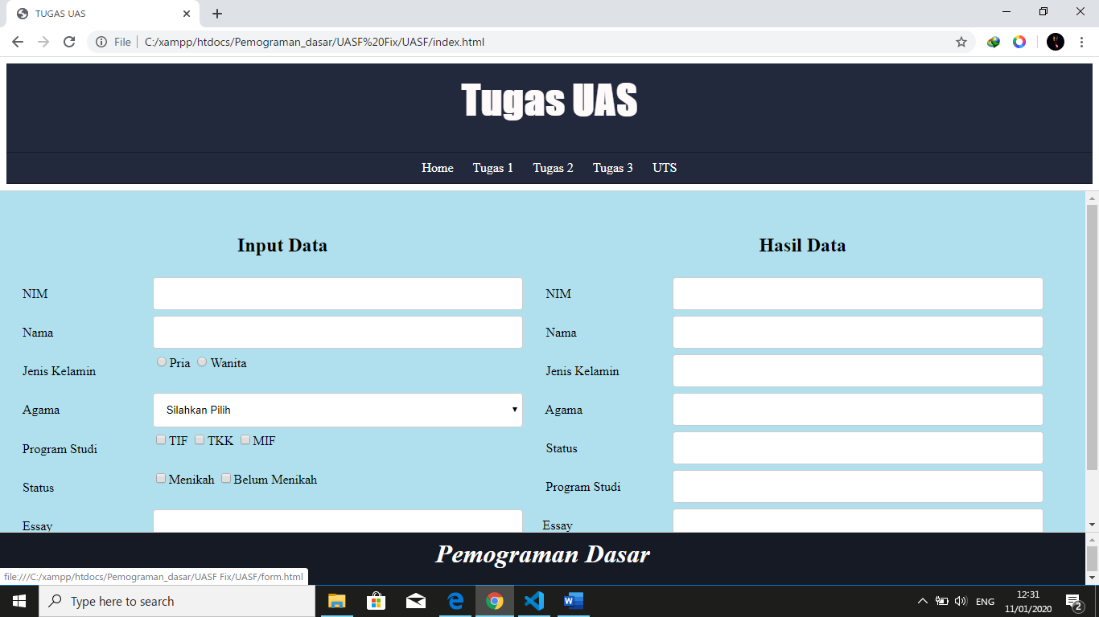

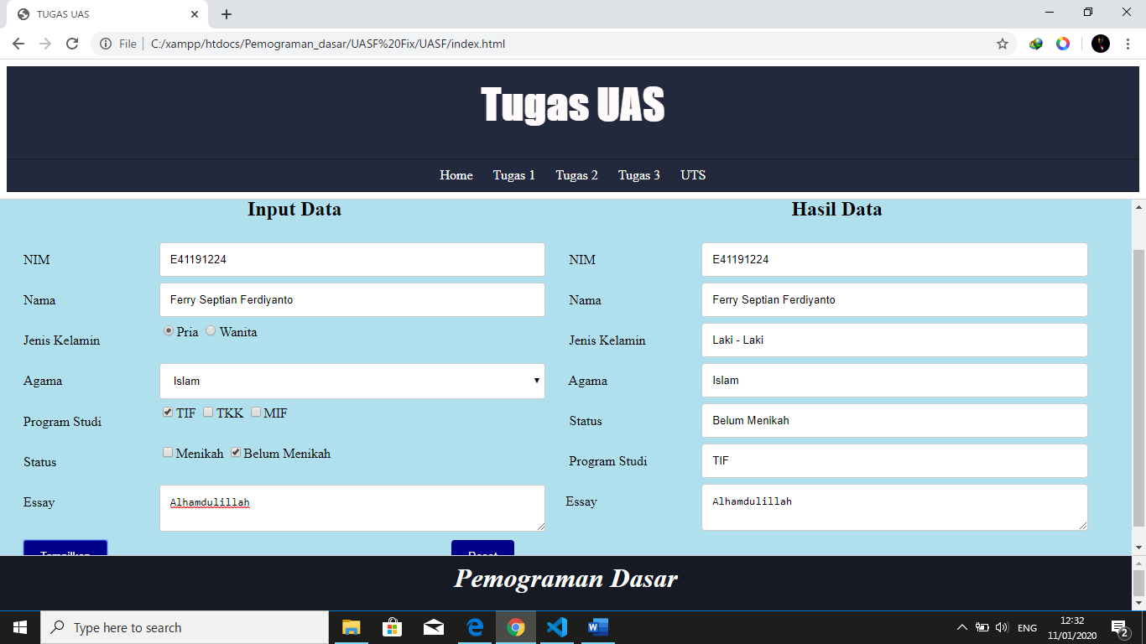

**Script:**

<!DOCTYPE html>

<html>

<head>

    <title>Form</title>

    <link rel="stylesheet" type="text/css" href="cssform.css">

</head>

<body bgcolor="blue red">

    <div class="container">

        <form autocomplete="off" name="mahasiswa">

            <div class="col-50">

                <center><h2>Input Data</h2></center>

                <div class="row">

                    <div class="col-25">

                        <label>NIM</label>

                    </div>

                    <div class="col-75">

                        <input type="text" name="nim">

                    </div>

                </div>

                <div class="row">

                    <div class="col-25">

                        <label>Nama</label>

                    </div>

                    <div class="col-75">

                        <input type="text" name="nama">

                    </div>

                </div>

                <div class="row">

                    <div class="col-25">

                        <label>Jenis Kelamin</label>

                    </div>

                    <div class="col-75">

                        <input type="radio" name="LK" value="Pria">Pria

                        <input type="radio" name="WN" value="Wanita">Wanita

                    </div>

                </div>

                <div class="row">

                    <div class="col-25">

                        <label>Agama</label>

                    </div>

                    <div class="col-75">

                        <select name="agama">

                            <option value="Silahkan Pilih">Silahkan Pilih</option>

                            <option value="Islam">Islam</option>

                            <option value="Kristen">Kristen</option>

                            <option value="Hindu">Hindu</option>

                            <option value="Budha">Budha</option>

                            <option value="Khonghucu">Khonghucu</option>

                        </select>

                    </div>

                </div>

                <div class="row">

                    <div class="col-25">

                        <label>Program Studi</label>

                    </div>

                    <div class="col-75">

                        <input type="checkbox" name="TIF"><span>TIF</span>

                        <input type="checkbox" name="TKK"><span>TKK</span>

                        <input type="checkbox" name="MIF"><span>MIF</span>

                    </div>

                </div>

                <div class="row">

                    <div class="col-25">

                        <label>Status</label>

                    </div>

                    <div class="col-75">

                        <input type="checkbox" name="Menikah"><span>Menikah</span>

                        <input type="checkbox" name="BelumMenikah"><span>Belum Menikah</span>

                    </div>

                </div>

                <div class="row">

                    <div class="col-25">

                        <label>Essay</label>

                    </div>

                    <div class="col-75">

                        <textarea name="essay"></textarea>

                    </div>

                </div>

                <div class="row">

                    <div class="col-25">

                        <input type="button" value="Tampilkan" onclick="data()">

                    </div>

                    <div class="col-50"></div>

                    <div class="col-25">

                        <input type="reset" name="reset" value="Reset">

                    </div>

                </div>

            </div>

            <div class="col-50">

                <center><h2>Hasil Data</h2></center>

                <div class="row">

                    <div class="col-25">

                        <label>&nbsp;NIM</label>

                    </div>

                    <div class="col-75">

                        <input type="text" name="nimout">

                    </div>

                </div>

                <div class="row">

                    <div class="col-25">

                        <label>&nbsp;Nama</label>

                    </div>

                    <div class="col-75">

                        <input type="text" name="namaout">

                    </div>

                </div>

                <div class="row">

                    <div class="col-25">

                        <label>&nbsp;Jenis Kelamin</label>

                    </div>

                    <div class="col-75">

                        <input type="text" name="jkout">

                    </div>

                </div>

                <div class="row">

                    <div class="col-25">

                        <label>&nbsp;Agama</label>

                    </div>

                    <div class="col-75">

                        <input type="text" name="agamaout">

                    </div>

                </div>

                <div class="row">

                    <div class="col-25">

                        <label>&nbsp;Status</label>

                    </div>

                    <div class="col-75">

                        <input type="text" name="statusout">

                    </div>

                </div>

                <div class="row">

                    <div class="col-25">

                        <label>&nbsp;Program Studi</label>

                    </div>

                    <div class="col-75">

                        <input type="text" name="prodiout">

                    </div>

                </div>

                <div class="row">

                    <div class="col-25">

                        <label>Essay</label>

                    </div>

                    <div class="col-75">

                        <textarea name="essayout"></textarea>

                    </div>

                </div>

            </div>

        </form>

    </div>

</body>

<script>

    function data() {

    // body...

    /*menyimpan inputan dari form berdasarkan name di dalam variabel*/

    var nim = (document.mahasiswa.nim.value);

    var nama = (document.mahasiswa.nama.value);

    var agama = (document.mahasiswa.agama.value);

    var essay = (document.mahasiswa.essay.value);

    var jk = "";

    if(document.mahasiswa.LK.checked == true){

        jk = "Laki - Laki"

    }else if (document.mahasiswa.LK.checked == true) {

        jk = "Wanita"

    }

    var status = "";

    if (document.mahasiswa.Menikah.checked == true) {

        status = "Menikah";

    }else if (document.mahasiswa.BelumMenikah.checked == true) {

        status = "Belum Menikah";

    }else {

        status = "";

    }

    var prodi = "";

    if (document.mahasiswa.TIF.checked == true) {

        prodi = "TIF";

    }else if (document.mahasiswa.MIF.checked == true) {

        prodi = "MIF";

    }else if (document.mahasiswa.TKK.checked == true) {

        prodi = "TKK";

    }else{

        prodi = "";

    }

                    /*selese*/

    /*mengeluarkan data dari dalam variabel*/

    document.mahasiswa.nimout.value = nim;

    document.mahasiswa.namaout.value = nama;

    document.mahasiswa.jkout.value = jk;

    document.mahasiswa.agamaout.value = agama;

    document.mahasiswa.statusout.value = status;

    document.mahasiswa.prodiout.value = prodi;

    document.mahasiswa.essayout.value = essay;}

</script>

</html>

1. **Input Nilai (Tugas 2)**

**Screenshot :**

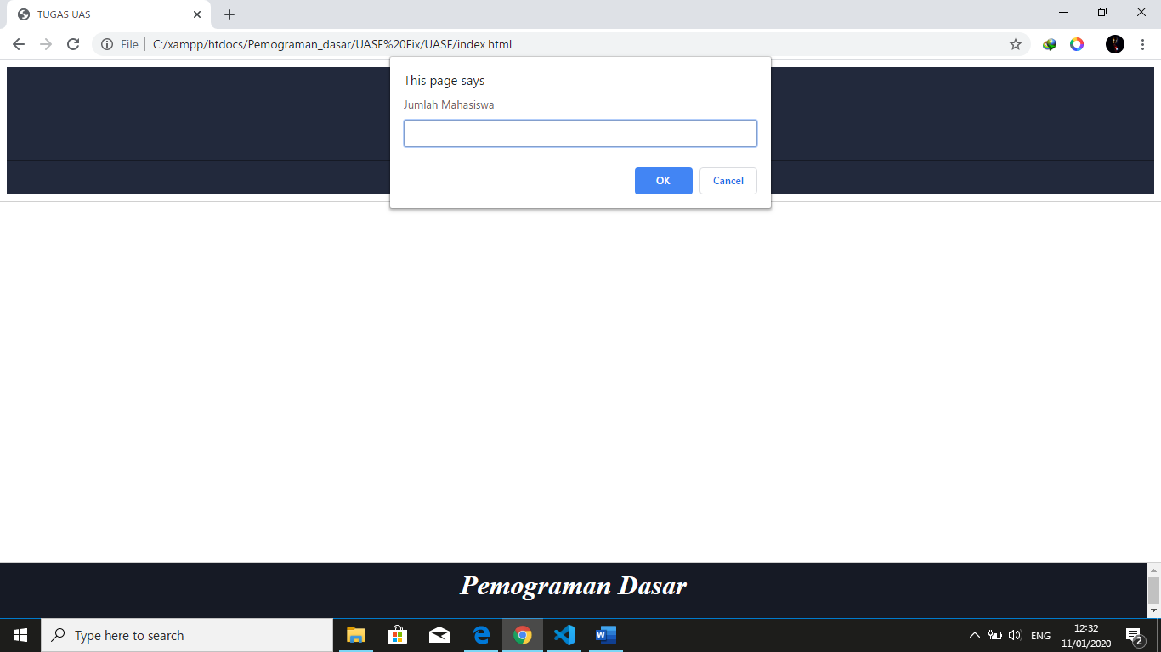



**Script :**

<!DOCTYPE html>

<html lang="en">

<head>

    <meta charset="UTF-8">

    <meta name="viewport" content="width=device-width, initial-scale=1.0">

    <meta http-equiv="X-UA-Compatible" content="ie=edge">

    <title>Tugas</title>

    <center>

    <script src="while.js"></script>

</head>

<body background="24073.jpg">

    <script>

        ////////////////////// DO While /////////////////////

var jumlah,nama, nilai , Grade , n  ,nim

jumlah = prompt("Jumlah Mahasiswa" + "")

n = 1

do{

nama = prompt("Nama Mahasiswa " + n + "")

nim = prompt("NIM Mahasiswa " + "")

nilai = prompt("Nilai Mahasiswa " + n + "")

nilai=eval(nilai)

document.write("<h2 align=center> Cek Grade Nilai Mahasiswa </h2>")

{

    if(nilai >=90  && nilai <=100){

    Grade = " A "

    }

    else if(nilai >=80 && nilai <90)

    {

    Grade  = " B "

    }

    else if(nilai >=60 && nilai <80)

    {

    Grade = " C "

    }

    else if(nilai >=50 && nilai <60)

    {

    Grade = " D "

    }

     else if(nilai >=0 && nilai <59)

    {

     Grade = " E "

    }

    document.write("<h2>Mahasiswa "+n+ "</h2>" + "</br>")

    document.write("Nama Mahasiswa: "+ nama + "</br>")

    document.write("NIM Mahasiswa: "+ nim + "</br>")

    document.write("Nilai Mahasiswa: "+ nilai + "</br>")

    document.write("Status Nilai Mahasiswa:  "+ Grade + "</br>")

    document.writeln("<hr width='850' align='center' color='yellow'> </hr>")

    document.writeln("<hr width='850' align='center' color='yellow'> </hr>")

    }

    n++ }

    while(n<=jumlah)

    </script>

</body>

</html>

1. **Menghitung Luas dan Keliling (Tugas 3)**

**Screenshot :**

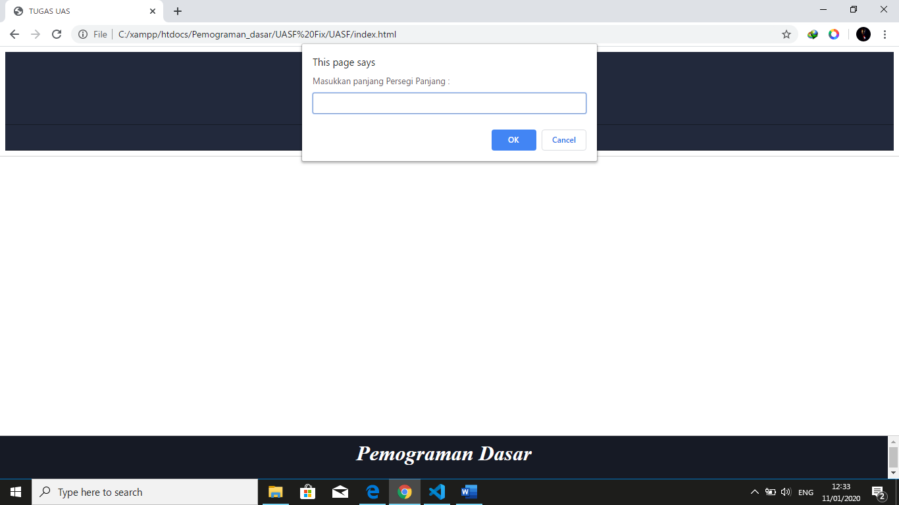



**Script :**

<!DOCTYPE html>

<html lang="en">

<head>

    <meta charset="UTF-8">

    <meta name="viewport" content="width=device-width, initial-scale=1.0">

    <meta http-equiv="X-UA-Compatible" content="ie=edge">

    <title>Document</title>

</head>

<body>

    <script>

        var luas,keliling,panjang,lebar

        panjang = prompt("Masukkan panjang Persegi Panjang :" +"")

        lebar = prompt("Masukkan lebar Persegi Panjang :" +"")

        luas = panjang * lebar;

        keliling = (2 * panjang) + (2 * lebar);

        document.write("Hasil Luas Persegi Panjang adalah "+luas);

        document.write("<br>Hasil Keliling Persegi Panjang adalah "+keliling);

    </script>

</body>

</html>

1. **Perulangan (Tugas UTS)**

**Screenshot :**

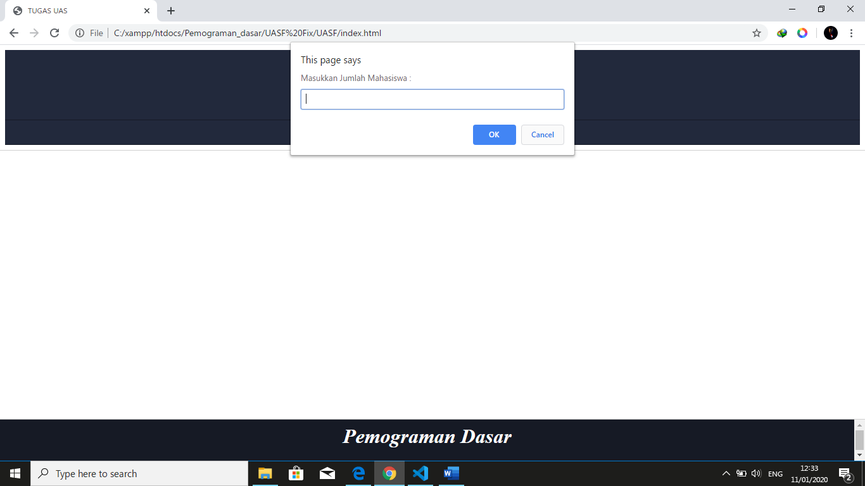

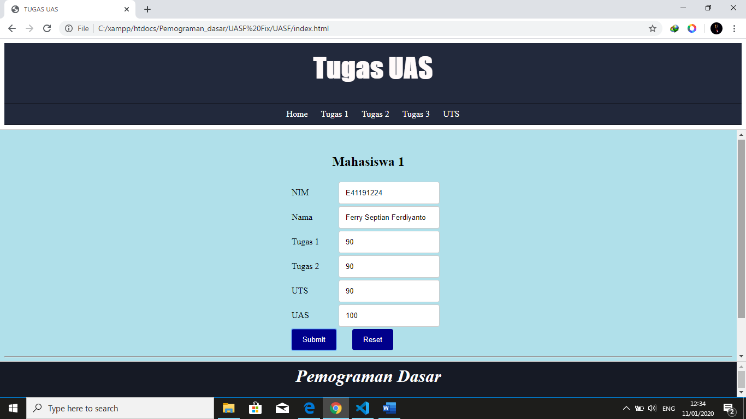

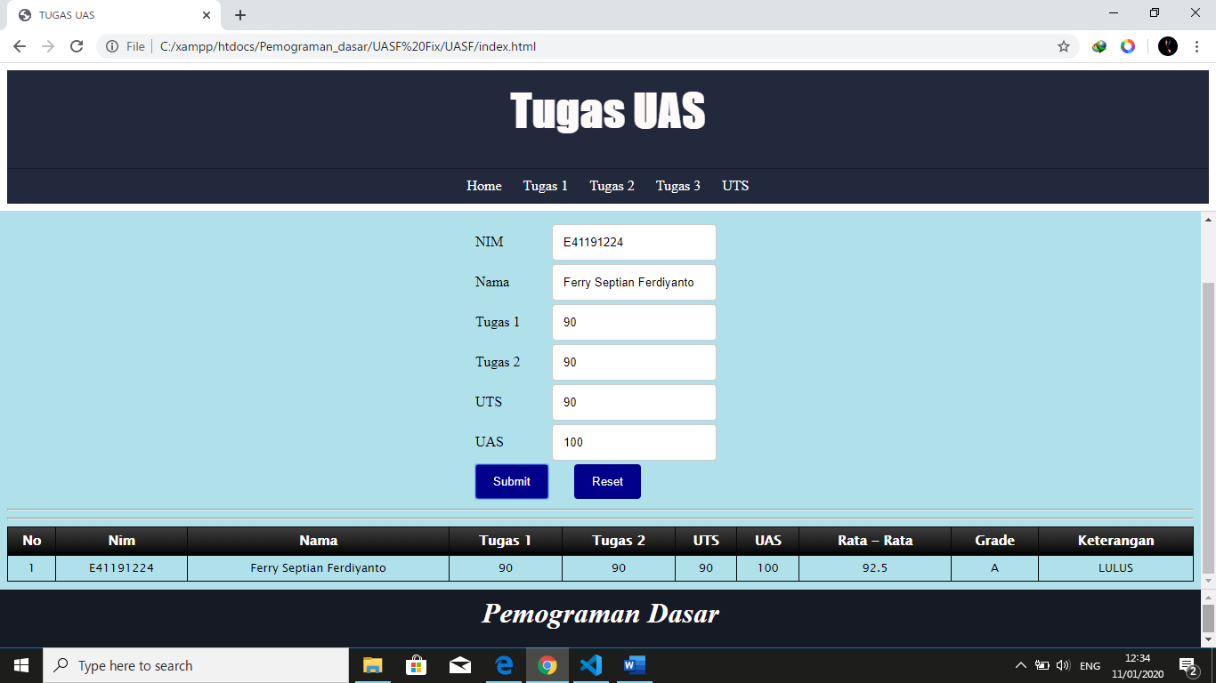

**Script :**

<!DOCTYPE html>

<html lang="en">

<head>

    <meta charset="UTF-8">

    <meta name="viewport" content="width=device-width, initial-scale=1.0">

    <meta http-equiv="X-UA-Compatible" content="ie=edge">

    <title>Masukkan Data Mahasiswa</title>

    <link rel="stylesheet" href="cssuts.css">

    <center>

    <script type="text/javascript">

        var jumlah = prompt("Masukkan Jumlah Mahasiswa : ")

        for(var n=1;n<=jumlah;n++)

        {

            document.write("<br>")

            document.write("<table>")

            document.write("<h2>Mahasiswa "+n+"</h2>")

            document.write("<tr>")

            document.write("<td>NIM</td>")

            document.write("<td><input type='text' id='nim"+n+"'></td>")

            document.write("</tr>")

            document.write("<tr>")

            document.write("<td>Nama</td>")

            document.write("<td><input type='text' id='nama"+n+"'></td>")

            document.write("</tr>")

            document.write("<tr>")

            document.write("<td>Tugas 1</td>")

            document.write("<td><input type='text' id='tugas_1"+n+"'></td>")

            document.write("</tr>")

            document.write("<tr>")

            document.write("<td>Tugas 2</td>")

            document.write("<td><input type='text' id='tugas_2"+n+"'></td>")

            document.write("</tr>")

            document.write("<tr>")

            document.write("<td>UTS</td>")

            document.write("<td><input type='text' id='uts"+n+"'></td>")

            document.write("</tr>")

            document.write("<tr>")

            document.write("<td>UAS</td>")

            document.write("<td><input type='text' id='uas"+n+"'></td>")

            document.write("</tr>")

        }

            document.write("<tr><td><input type='button' value='Submit' onclick='data("+jumlah+")'></td>")

            document.write("<td><input type='reset' value='Reset'></td></tr>")

        function data(jml)

        {

            var td = ""

            for(var t=1;t<=jml;t++){

                var nim = document.getElementById('nim' + t).value

                var nama = document.getElementById('nama' + t).value

                var tugas_1 = parseFloat(document.getElementById('tugas_1' + t).value)

                if (isNaN(tugas_1)) {

                    tugas_1 = 0.0

                }

                var tugas_2 = parseFloat(document.getElementById('tugas_2' + t).value)

                if (isNaN(tugas_2)) {

                    tugas_2 = 0.0

                }

                var uts = parseFloat(document.getElementById('uts' + t).value)

                if (isNaN(uts)) {

                    uts = 0.0

                }

                var uas = parseFloat(document.getElementById('uas' + t).value)

                if (isNaN(uas)) {

                    uas = 0.0

                }

                var total = tugas_1+tugas_2+uts+uas

                var rata = total/4

                var nilai

                var ket

                if (rata >= 85 && rata <= 100)

                {

                    nilai = "A";

                    ket = "LULUS";

                }

                else if (rata >= 70 && rata <= 84)

                {

                    nilai = "B";

                    ket = "LULUS"

                }

                else if (rata >= 60 && rata <= 69)

                {

                    nilai = "C"

                    ket = "LULUS"

                }

                else if (rata >= 50 && rata <= 59)

                {

                    nilai = "D"

                    ket = "TIDAK LULUS"

                }

                else if (rata < 50 )

                {

                    nilai = "E"

                    ket = "TIDAK LULUS"

                }

                td += "<tr>"

                td += "<td>" + t + "</td>";

                td += "<td>" + nim + "</td>";

                td += "<td>" + nama + "</td>";

                td += "<td>" + tugas_1 + "</td>";

                td += "<td>" + tugas_2 + "</td>";

                td += "<td>" + uts + "</td>";

                td += "<td>" + uas + "</td>";

                td += "<td>" + rata + "</td>";

                td += "<td>" + nilai + "</td>";

                td += "<td>" + ket + "</td>";

                td += "</tr>"

            }

            document.getElementById('isi').innerHTML = td;

        }

    </script>

    <table border="1" class="blueTable">

        <thead>

            <tr>

                <th>No</th>

                <th>Nim</th>

                <th>Nama</th>

                <th>Tugas 1</th>

                <th>Tugas 2</th>

                <th>UTS</th>

                <th>UAS</th>

                <th>Rata - Rata</th>

                <th>Grade</th>

                <th>Keterangan</th>

            </tr>

        </thead>

        <tbody id="isi">

        <body> <body bgcolor ="blue sea"></body>

        </center>

        <HR WIDTH="%">

            <HR WIDTH="%">

        </tbody>

    </table>

</html>